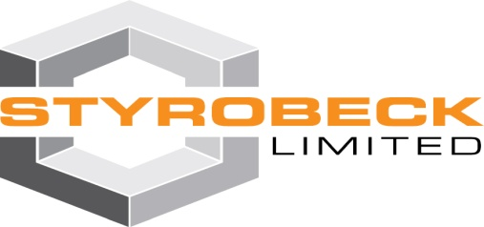

**STYROBECK GEOFOAM**

**Expanded Polystyrene (EPS) blocks used as a lightweight structural fill providing a cost effective solution.**

Supplied in a range of densities and sizes to suit the engineering design requirements. Choosing the correct density will depend on the compressive loading required. All blocks can be cut to suit specific design requirements, including penetrations, angles and two dimensional profiles. Geofoam blocks are made with fire retardant material.

**Standard Block Sizes**

5.02 x 1.22 x 0.53 (3.25m3) Note: Blocks can be cut to other sizes

such as ½ blocks for joint staggering

Table of physical properties of EPS

|  |  |  |  |  |  |  |  |
| --- | --- | --- | --- | --- | --- | --- | --- |
| **PHYSICAL PROPERTY** | **UNIT** | **SL** | **S** | **M** | **H** | **VH** | **TEST METHOD** |
| Compressive stress at 10% deformation (min) | kPa | 70 | 85 | 105 | 135 | 165 | AS 2498.3 |
| Cross-breaking strength (min) | kPa | 135 | 165 | 200 | 260 | 320 | AS 2498.4 |
| Rate of water vapour transmission (max) measured parallel to rise at 23°C | mg/m2s | 630 | 580 | 520 | 460 | 400 | AS 2498.5 |
| Dimensional stability of length, width, thickness (max) at 70°C, dry condition 7 days | % | 1 | 1 | 1 | 1 | 1 | AS 2498.6 |

**Advantages**

* Lightweight & easy to transport
* High compressive strength
* Cost effective
* Ease of placement especially in sites with limited access
* Durable long term (will not decompose)

**Applications**

* Road embankments
* Bridge abutments
* Causeways
* Protection of underground services (Drain & sewer lines)
* Retaining wall fill

**Chemical resistance**

EPS block is resistant to soaps and inorganic substances   
such as dilute acids, alkalis and salt solutions.

It is attacked by organic solvent, including hydrocarbon fuels   
and lubricants.